|  |
| --- |
| **>** Designed by: Abdullah M. Abdul-Hadi    **>** Project: Dot Matrix Driving    **>** Date: 7-April-2010 |

    Data display design and menufactures a large selection of both indoor and outdoor moving message display, using LED (Light Emitted Diode). Data lines are easy to set up, program, handle, and are becomming increasingly popular in airports, high street outlets, and auctions to transmit information to large groups of people both quickly and effciently.

     This is a tutorial on using two colors 8x8 dot matrix, the matrix display the word "الله"  and shift the word up, then repeated in loop. I used in this tutorial PIC16F877A, with 74HC164 (8-bit) shift register (serial in-parallel out).

    I wrote the program in C, and I putted the hex. file of the code in file cabinet section, with name "Matrix" , for more information please e-mail me.

The schematic of the circuit shown in Fig.(1).

[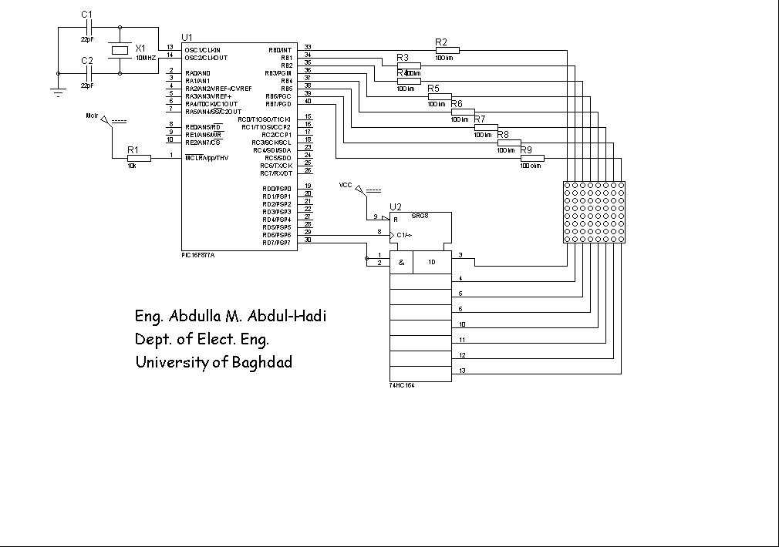](http://www.pic-tronics.com/images/PICMicro/Dot20Matrix.jpg)

Fig.(1)

   The Circuit work as follow, in the beginning the microcontroller send a pulse to shift register used to select a new row from the dot matrix after each negative going clock pulse.

   when the shift register select row1, PORTB give an output to make a certain LEDs ON, e.g. we want to make the first 3 LEDs from the first row ON and other leds OFF,  PORTB=0b11111000, may you said why I put "0" ,to make these LEDs active, because the cathode terminal of the LEDs connect to PORTB, if you need further details you can contact me.

|  |
| --- |
| **Source Code** |
| /*****************************/  /* Author: Abdullah M. Abdul-Hadi      */  /* Date: 7-April-2010                       */  /* [www.pic-tronics.com](http://www.pic-tronics.com)                    */  /*****************************/    #include <16f877a.h> #include <defs_877.h> #use     delay(clock=10000000) #fuses   hs,nowdt,nocpd,nolvp,noprotect    #byte portb=0x06   #byte portd=0x08  #bit  clock=portd.6 #bit  data=portd.7    unsigned int8 i,j,index1,n, addr[11]={0xEA,0xEA,0x2A,0x2A,0x2A,0x2A,0xAA,0x82,0xFF,0xFF,0xFF}, cont[11];    void main() {      set_tris_b(0x00);      set_tris_d(0x00);      while(1)     {         for(n=0;n<=99;n++)        {             data=1;                 for(i=0;i<=7;i++)             {                     clock=1;                    portb=addr[i];                 delay_ms(1);                 clock=0;                 data=0;              }         }            for(j=0;j<=10;j++)          {             cont[j]=addr[j];         }           for(j=0;j<=9;j++)            {             addr[j]=cont[j+1];           }         addr[10]=cont[0];      } } |